KE51 – Create Profit Center

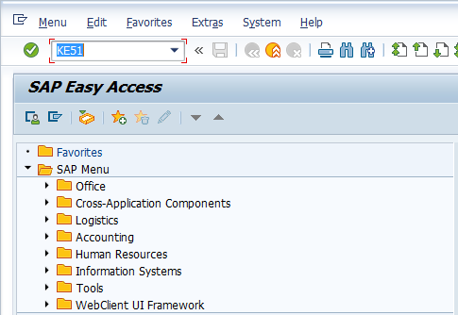

- Input KE51 in Transaction Box and press Enter key

Set Controlling Area Screen.

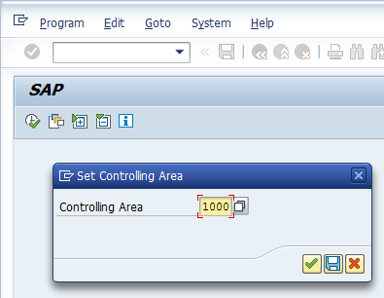

- Controlling Area: Input or select controlling area with the help of F4 key
Press Enter key

Create Profit Center Initial Screen.

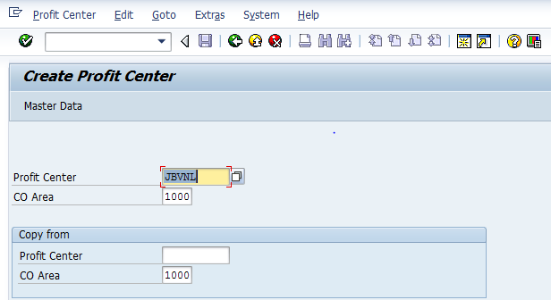

- Profit Center: Input Profit Center to be created
Press Enter key

Create Profit Center Screen.

Basic Data Tab

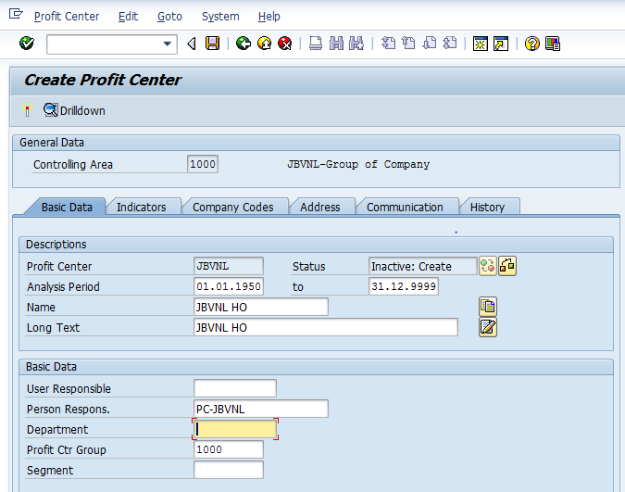

- Analysis Period: Input or Select analysis period with the help of F4 key (i.e. it is the period for which the profit center will be active)
- Name: Input short description of profit center
- Long Text: Input long description of profit center
- Person Respons.: Input person responsible for respective profit center
- Profit Ctr Group: Input or select the profit center group with the help of F4 key

Select Company Codes tab

Create Profit Center Screen.

Compnay Codes Tab

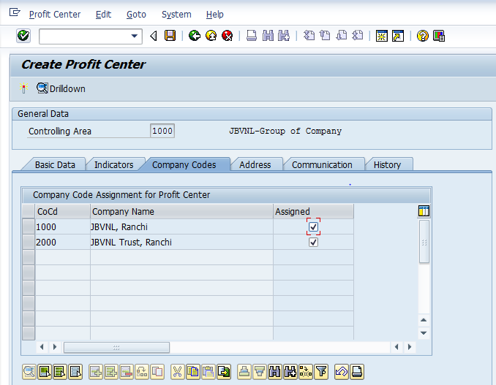

- Assigned: Select relevant company code for which profit center need to be assigned
Click on Activate button.

The profit center has been created message appears at bottom of the screen

Manual End

